♀16. Hierophant (Teacher/Student or DNA-mRNA)—Track 20 
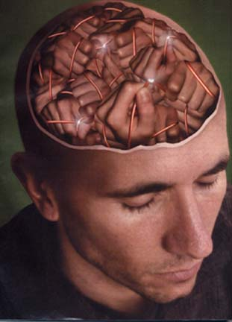
Within the past five years, neuroscientists have discovered that the brain does indeed change throughout life—and that such revision is a good thing. The new cells and connections that we and others have documented may provide the extra capacity the brain requires for the variety of challenges that individuals face throughout life. Such plasticity offers a possible mechanism through which the brain might be induced to repair itself after injury or disease. It might even open the prospect of enhancing an already healthy brain’s power to think and ability to feel.

The symbolism of healing is very ancient indeed, probably as old as the species. Evidence of healing behaviors has been observed in primates other than human beings, especially chimpanzees (e.g. the application of certain leaves to heal wounds; Rosen, 1992). Our own species evolved in circumstances of great vulnerability, threatened by the elements, by predators, hostile neighbors, and malevolent forces bringing disease and death. In such conditions it is not surprising that healers and healing practices should emerge.


